**Attahadi university**

**Faculty of pharmacy**

**Department of pharmaceutical and industrial pharmacy**

**Evaluation of self-medication with over the counter (OTC) among Attahadi university students**

**By:**

**Abdullah Salah Alshibani**

**Rami Khaled Alali**

**Supervised by:**

**Prof. Abdurrahim Abdalsalam Elouzi**

**Graduation project submitted to complete Bachelors degree in pharmaceutical sciences**

**(2022-2023)**



**Attahadi university**

**Faculty of pharmacy**

**Department of pharmaceutical and industrial pharmacy**

**Evaluation of self-medication with over the counter (OTC) among Attahadi university students**

**By:**

**Abdullah Salah Alshibani**

**Rami Khaled Alali**

**Supervised by:**

**Prof. Abdurrahim Abdalsalam Elouzi**

**Graduation project submitted to complete Bachelors degree in pharmaceutical sciences**

**(2022-2023)**

الأهداء

الحمد لله وكفى والصلاة على الحبيب المصطفى وأهله ومن وفى أما بعد :

نهدي ثمرة هذا الجهد المتواضع إلى من وهبونا الحياة والأمل، والنشأة على شغف الاطلاع والمعرفة، ومن علمونا ان نرتقي سلم الحياة بحكمة وصبر؛ براً وإحساناً و وفاءٌ لهما: والدينا

إلى من وهبنا الله نعمة وجودهم في حياتنا ومن كانوا عوناً في رحلة بحثنا: عائلتنا واخواننا

إلى جميع دكاترتنا الكرام ممن لم يتوانوا في مد يد العون لنا

إلى الذي وقف بجانبنا، وساندنا في إنهاء هذه الخطوة في رحلتنا الدراسية: الدكتور عبدالرحيم عبدالسلام العوزي

)نهديكم عملنا المتواضع(

}وَمَا تَوْفِيقِي إِلَّا بِاللَّهِ ۚ عَلَيْهِ تَوَكَّلْتُ وَإِلَيْهِ أُنِيبُ{

-List of Content :

1-Abstract ……………………………………………………….………( 5 )

2- Key words…………………………………………………………....( 6 )

3-Aim………………………………………………………………….... ( 7 )

4-Introduction………………………………………………….………..( 8 )

4.1-History of drugs

4.2- Classification of medicines

4.3- Over the counter drugs

4.4- Common type of OTC drugs

4.5- Misuses

4.6- OTC drugs safety

4.7-The future of OTC drugs

4.8- Over the counter medication for pregnancy

4.9- The correct uses of over the counter drugs

4.10- the role of pharmacist in self-care and self-medication

5- Methodology…………………………….……………….……………(19)

6- Results and Discussion………………………………….………... ..(20)

7- Conclusion………………………………………………..….………. (40)

8- References…………………………………………………………… (41)

**1-Abstract:**

OTC drugs, or non-prescription drugs, are medicines available without a doctor's prescription for common health issues like pain, headaches, colds, and allergies. They are regulated by the FDA to ensure effectiveness and safety. Misuse can result from improper dosages, disregarding warnings, taking medications without a healthcare provider, using expired medications, or giving children medications. To ensure OTC drug safety, follow instructions carefully, avoid overdosing, consult a healthcare provider, be aware of potential interactions, store medications properly, avoid expired ones, and dispose of unused ones. Be cautious with herbal and dietary supplements and keep a record of medications to avoid interactions and potential risks.

The study at Attahadi University in Libya used a specially designed questionnaire with 20 multiple-choice questions to understand student behavior around over-the-counter medicines. The 200 questionnaires were distributed directly to university students, on July 17-24 in 2023 ensuring an accurate representation of the student population.

In this study show that over-the-counter (OTC) drug use found that many respondents were unaware of the advantages and disadvantages of using these medications, which could result in inappropriate use or potential injury. The most widely used class of OTC drugs were painkillers, and many people who took them complained of side effects. A sizable portion of people mix various OTC medications to treat multiple ailments, which can be risky. Prioritizing safety and efficacy is key, and it is crucial to carefully study labels and seek professional advice as necessary.

**2-Key words:**

|  |  |
| --- | --- |
| **Abbreviation** | **Meaning** |
| OTC | Over the counter |
| SM | Self-medication |
| WHO | World health organization |
| NSAIDs | Non steroid anti-inflammatory drugs |
| FDA | Food & Drug administration |
| GIT | Gastro-intestinal tract |
| MAOIs | Monoamine oxidase inhibitors |
| POM | Prescription only medicine |

Table 1 : show the meanings of abbreviations in this search.

**3-Aim:**

The aim of our study :

-To find out to what extent students use OTC drugs as self-medication.

-To provide students with safe and effective options for self-treatment of minor health conditions and symptoms without the need for a prescription.

-To improve the health and well-being of individuals by providing them with access to safe and effective medications to manage minor health concerns.

# 

Figure 1 : show some OTC drugs with different shapes and sizes.

# 4.Introduction:

# 4.1 History of drugs:

The history of drugs spans thousands of years, involving the use of plant-based substances for medicinal, spiritual, and recreational purposes. Ancient civilizations like Sumerians, Egyptians, and Chinese used opium for medicinal purposes. In the Classical Period, Greeks and Romans used drugs like opium and cannabis for medicinal purposes (1). Drug use became associated with witchcraft and sorcery during the Middle Ages and Renaissance (2). European exploration led to the discovery of new drugs like tobacco, coca leaves, and psychoactive plants. Advances in medicine and chemistry in the 19th and early 20th centuries led to the isolation and synthesis of active compounds, such as morphine and cocaine.

**4.2 classification of medicines:**

Regulators around the world impose different restrictions on drug availability, such as prescription status, to protect the health. Different drug categories, such as POM & OTC Drugs are classified into different categories based on their characteristics. Major factors that affect drug classification are the self-diagnosis nature of diseases and safety profile of drugs. Drugs for catastrophic diseases and drugs for minor ailments are usually classified into different categories, which are prescription drugs and non-prescription drugs (3). Drug status can be re-classified downward or upward depending mainly on the safety information being obtained from market experiences (4). For example, in the UK, diclofenac (NSAIDs) was re-classified upward from non-prescription to prescription status because an increased risk of cardiovascular diseases was found (5). Conversely, to increase drug accessibility, in the US, loratadine was re-classified from prescription to non-prescription status when its safety information was confirmed after placing it on the market for nine years (6). There is a precedent, then, that drug regulatory agencies make the final decision when assessing benefits and risks to re-classify drugs into appropriate categories in order to ensure patient safety while maximizing timely access to drugs.

**4.2.1 Prescription-Only Medications (POM):**

- Prescription medications can only be obtained with a valid prescription from a licensed healthcare professional, such as a doctor or nurse practitioner.

- These medications are typically used for the treatment of more complex or serious health conditions that require professional evaluation, diagnosis, and monitoring (6).

- Prescription drugs often have a higher potential for side effects, drug interactions, or misuse and require proper medical supervision.

**4.2.2 Over-the-Counter (OTC) Medications:**

- OTC medications are available for purchase directly from pharmacies, supermarkets, or other retail outlets without a prescription.

- Self-medication has traditionally been defined as “the taking of drugs, herbs or home remedies on one's own initiative, or on the advice of another person, without consulting a doctor (7)

-Families, friends, neighbours, the pharmacist, previous prescribed drug, or suggestions from an advertisement in newspapers or popular magazines are common sources of self-medications.

- These medications are considered safe and effective for self-diagnosis and self-treatment of common health conditions (10).

**4.3 Over the counter**

OTC drugs commonly referred to as non-prescription drugs, are medicines that can be bought without a doctor's prescription. They are extensively offered at supermarkets, pharmacies, and quick-service restaurants (8). These medications are used to treat some common health issues, including pain, headaches, colds, and allergies (9). OTC medications can be beneficial for treating minor health issues or relieving symptoms, but they should always be taken carefully and according to the directions on the packaging. Government organizations, such as the Food and Drug Administration (FDA)(10), regulate over-the-counter medications to guarantee their effectiveness and safety for consumer use (11). Although over-the-counter (OTC) medications can be bought without a prescription, it's important to remember that they still count as medications and should be used with caution, especially if you have any pre-existing medical conditions or are already taking prescription medication (12). It is advised to speak with a healthcare expert if you are unsure whether an over-the-counter medication is appropriate for you (13).

**4.4 Common types of OTC drugs:**

There are several common groups or categories of over-the-counter (OTC) drugs. Here are some examples:

1. Pain relievers: This group includes drugs such as acetaminophen and ibuprofen, which are used to relieve mild to moderate pain and reduce fever (14). These drugs work by blocking the production of certain chemicals in the body that cause pain and inflammation (15).

2. Cough and cold medicines: This group includes drugs such as cough syrups, throat lozenges, and nasal decongestants. These drugs are used to treat symptoms associated with colds, flu, and allergies, such as coughing, congestion, and sore throat (16).

3. Antihistamines: This group of drugs is used to treat allergies and allergic reactions. They work by blocking the action of histamine, a chemical that is produced by the body in response to allergens (17).

4. Digestive aids: This group includes drugs such as antacids, laxatives, and anti-diarrheals. These drugs are used to treat common digestive problems such as heartburn, indigestion, constipation, and diarrhea (18).

5. Topical creams and ointments: This group includes drugs such as topical pain relievers, anti-itch creams, and acne treatments. These drugs are applied directly to the skin and are used to treat a variety of skin conditions and minor injuries (19).

6. Vitamins and supplements: This group includes products such as multivitamins, herbal supplements, and probiotics. These products are used to support overall health and wellness, and to supplement the nutrients that may be lacking in a person's diet (20).

-These are just a few examples of the common groups of OTC drugs. It is important to note that different countries may have different regulations and classifications for OTC drugs, and some drugs that are available without a prescription in one country may require a prescription in another (21).

|  |  |  |  |
| --- | --- | --- | --- |
| TYPES | EXAMPLE | SIDE EFFECT | DRUG INTERACTIONS |
| Pain relievers | Acetaminophen  ibuprofen | Nausea stomach pain,  heartburn, dizziness | Warfarin, aspirin, other nonsteroidal  anti-inflammatory drugs (NSAIDs),  certain blood pressure medications |
| Cough | Dextromethorphan codeine | Drowsiness, dizziness, nausea, constipation | MAOIs, certain antidepressants, sedatives |
| cold | pseudoephedrine Phenylephrine | Increased heart rate,blood pressure, nervousness, insomnia | MAOIs, beta-blockers, certain  antidepressants |
| Antihistamines | Diphenhydramine loratadine | Drowsiness, dry mouth, blurred vision, constipation | Sedatives, tranquilizers, monoamine oxidase inhibitors (MAOIs) |
| . Digestive aids | 1-Omeprazole  2- Calcium carbonate aluminum hydroxide/magnesium hydroxide | 1-Headache, diarrhea, abdominal pain, increased risk of fractures  2-Constipation (calcium-based antacids), diarrhea (magnesium-based antacids) | 1. Clopidogrel (Plavix), certain antifungal medications (e.g., ketoconazole) 2. Certain antibiotics, iron supplements, tetracycline |

Table 2 : show type , example , side effect , and drug interaction of OTC drugs.

**4.5.1 Misuses of over the counter :**

when used correctly. The potential for abuse and misuse of OTC medications is one of the biggest concerns involved (22). When someone uses While OTC medications have some dangers, they are safe and efficient over-the-counter medication improperly, for as by taking higher doses than advised or using it for longer than advised, this is known as abuse (23). When someone uses an OTC drug to get high or for non-medical reasons, they are engaging in drug abuse (24).

**4.5.2 Some other misuses of OTC drugs :**

1: Combining several prescription drugs at once: This can result in drug interactions, which can have negative side effects (25).

2: Ignoring caution warnings: OTC medications have warning labels that advise patients about possible interactions and negative effects. The danger of negative effects can increase if these labels are ignored (26).

3: Taking OTC pharmaceuticals without contacting a healthcare provider: Despite having a pre-existing medical condition or taking other prescriptions, some people choose to take OTC medications without first speaking with a healthcare provider (27).

4: Using OTC medications that have expired: OTC medications have an expiration date after which they may no longer be safe or effective (28).

5: Giving children OTC medications: Children may need lesser doses of OTC medications than adults, and some medications may not be suitable for kids under a specific age. Before administering OTC medications to children, it is crucial to carefully read the label and speak with a healthcare provider (26).

It's crucial to carefully read the labels on OTC medications and adhere to the suggested amounts to prevent misuse (29). It is always better to speak with a medical expert if you have any questions or concerns. Keeping a record of all the prescriptions you take, including OTC medications, and giving it to your healthcare physician can also help to avoid interactions and make sure you're getting the right care (30).

**4.6 OTC drugs safety:**

To ensure OTC drug safety, it is important to read and follow the instructions on the packaging carefully. Do not exceed the recommended dose, and do not take the medication for longer than instructed. If you have any questions or concerns about taking an OTC medication, consult with a healthcare provider or pharmacist (31).

It is also important to be aware of potential interactions with other medications, as well as any pre-existing medical conditions. Be sure to inform your healthcare provider or pharmacist of any medications you are currently taking, including prescription and OTC drugs, as well as any medical conditions you have, before taking a new OTC medication (32).

In addition, it is important to store OTC medications properly, in a cool and dry place, out of reach of children and pets. Do not use expired medications, and dispose of unused medication properly (33).

**4.6.1 some additional points to consider about OTC drug safety:**

1: Be aware of potential side effects: OTC drugs, like all medications, can have side effects. Some common side effects of OTC drugs include drowsiness, dizziness, upset stomach, and allergic reactions. Read the packaging carefully to learn about potential side effects, and contact a healthcare provider if you experience any unexpected or severe side effects (34).

2: Consider your medical history: If you have a pre-existing medical condition, such as high blood pressure, diabetes, or liver disease, some OTC medications may not be safe for you to take. Be sure to inform your healthcare provider or pharmacist of any medical conditions you have before taking an OTC medication (35).

3: Avoid using multiple OTC medications together: Combining multiple OTC medications can increase the risk of side effects and interactions. If you need to take more than one medication, consult with a healthcare provider or pharmacist to ensure that the medications are safe to use together (36).

4: Take caution with herbal and dietary supplements: Herbal and dietary supplements, which are also available without a prescription, can interact with prescription and OTC medications. Be sure to inform your healthcare provider or pharmacist if you are taking any herbal or dietary supplements before taking an OTC medication (37).

5: Keep a record of the medications you take: Keeping a record of the medications you take, including prescription and OTC drugs, can help you avoid interactions and potential risks. Be sure to inform your healthcare provider or pharmacist of any changes in your medication regimen (38).

-In summary, OTC drugs can be a convenient and effective way to treat minor health issues, but they should be used with caution and according to the instructions on the packaging.

**4.7 The future of OTC drugs:**

The future of OTC drugs is likely to involve continued growth and innovation in the industry, driven by factors such as changing consumer preferences, advances in technology, and increasing demand for self-care options (39).

One trend that is likely to shape the future of OTC drugs is the growing use of digital health technologies and telemedicine (40). These technologies enable consumers to access healthcare services and information remotely, and can help to improve the convenience and accessibility of OTC medications. For example, digital health platforms may offer personalized recommendations for OTC medications based on a user's symptoms or health history (41).

Another trend is the increasing focus on natural and plant-based ingredients in OTC medications. As consumers become more interested in natural and alternative health remedies, companies may develop new OTC products that incorporate these ingredients (42). This trend could also lead to increased regulation and standardization of natural health products, to ensure their safety and effectiveness (43).

In addition, there is likely to be continued growth in the use of OTC medications for chronic conditions such as diabetes, hypertension, and asthma (44). As healthcare systems face increasing pressure to reduce costs and improve access to care, OTC medications may play a larger role in managing chronic conditions, particularly in lower-income or rural areas where access to healthcare services is limited (45).

the future of OTC drugs is likely to involve increased innovation and growth, driven by changing consumer preferences and advances in technology. As the healthcare landscape continues to evolve, OTC medications will likely play an increasingly important role in enabling consumers to manage their health and wellness (46).

**4.8 Over the counter medication for pregnancy**

It is important to note that pregnant women should always consult with their healthcare provider before taking any medication, including over-the-counter (OTC) drugs. Some OTC drugs are generally considered safe to use during pregnancy, but others may pose potential risks to the developing fetus (47).

-Here are some examples of OTC drugs that may be safe to use during pregnancy, but it is still important to consult with a healthcare provider before using them:

1. Acetaminophen (Tylenol): used for mild to moderate pain relief and fever reduction (41-48).

2. Antacids (Tums, Rolaids, Maalox): used for heartburn and indigestion relief (48.49).

3. Saline nasal spray (Ocean, Simply Saline): used for nasal congestion relief (48.49).

4. Docusate sodium (Colace): used for constipation relief (48.49).

5. Calcium carbonate (Tums): used for calcium supplementation, heartburn, and acid indigestion relief (48.49).

It is important to note that some OTC drugs, such as non-steroidal anti-inflammatory drugs (NSAIDs) like ibuprofen and naproxen, should be avoided during pregnancy as they may increase the risk of complications. Again, it is always best to consult with a healthcare provider before taking any medication during pregnancy (50).

**4.9 The correct uses of over the counter drugs**

Over-the-counter (OTC) medications are drugs that can be purchased without a prescription from a healthcare provider. They are used to treat a variety of common health conditions, such as pain, fever, allergies, colds, and digestive problems (51). Here are some tips for using OTC medications correctly:

1. Check the expiration date: Always check the expiration date before taking any medication. Expired medications may not be effective and could even be harmful (52).

2. Choose the right medication: There are many different OTC medications available for the same condition, so it's important to choose the right one for your symptoms. For example, if you have a headache, you might choose a pain reliever that specifically targets headaches rather than a general pain reliever (53).

3. Be aware of potential drug interactions: Some OTC medications can interact with prescription medications or other OTC medications, potentially causing harmful side effects. Be sure to tell your healthcare provider or pharmacist about all medications you are taking, including OTC medications, vitamins, and supplements (54).

4. Don't take OTC medications for too long: If you have been taking an OTC medication for several days and your symptoms have not improved, or if you are experiencing new symptoms, it's time to see a healthcare provider. OTC medications are intended for short-term use and should not be taken for extended periods of time (55).

5. Don't crush or break tablets: Unless the medication is specifically designed to be crushed or broken, you should not alter its form. This can affect the medication's effectiveness and may cause harmful side effects (56).

6. Be cautious with children: OTC medications can be safe and effective for children, but they should be used with caution. Always follow the dosage instructions carefully and consult with a healthcare provider or pharmacist before giving any medication to a child (57).

7. Use OTC medications as directed: OTC medications should be used only for the purpose for which they are intended. For example, a pain reliever should only be used to relieve pain, not as a sleep aid (58).

8. Read the label: Always read the label carefully before taking any medication. This will tell you the active ingredients, the dosage, and any warnings or precautions you should be aware of them (59).

9. Follow the dosage instructions: Take the medication exactly as directed on the label or as instructed by your healthcare provider. Do not exceed the recommended dose, and do not take the medication for longer than recommended (60).

10. Know the side effects: Be aware of the potential side effects of the medication, and stop taking it if you experience any adverse reactions (61).

11. Avoid interactions: Be sure to check with your healthcare provider or pharmacist before taking any new OTC medication, especially if you are taking prescription medications, have a chronic medical condition, or are pregnant or breastfeeding (62).

12. Store the medication properly: Store OTC medications according to the instructions on the label, in a cool, dry place away from children and pets (63).

13. Don't share medications: Do not share your OTC medications with others, even if they have the same symptoms as you (64).

14. Consult your healthcare provider: If your symptoms persist or worsen after taking an OTC medication, or if you have any concerns or questions about its use, consult your healthcare provider (65).

**4.10 the role of pharmacist in self-care and self-medication**

Community pharmacists are uniquely placed to provide support and advice to the general public compared with other health care professionals. The combination of location and accessibility means that most consumers have ready access to a pharmacy where health professional advice is available on demand. A high level of public trust and confidence in pharmacists’ ability to advise on nonprescription medicines is afforded to community pharmacists (66). Although there is a general global move to liberalize nonprescription markets, pharmacies in many countries still are the main suppliers of nonprescription medicines (66). Pharmacists are therefore in a position to facilitate consumer self-care and self-medication, which needs to be built on and exploited.

**5-Methodology:**

The study was carried out at Al-Tahhadi University Tripoli-Libya between May 2023 and July 2023. A specially created questionnaire with 20 multiple-choice questions was prepared by reviewing similar studies (Pakistan , Iran , Saudi Arabia ) and then approved by our supervisor.

It contains demographic characteristic (gender) , pattern of self-medication with OTC drugs , most used OTC drugs and the condition that lead to use , source of information about the mediation and other questions that present their knowledge and attitude .

The 200 questionnaires were personally distributed toward university students in total. The purpose of the questionnaire was to learn more about how students behaved around over-the-counter medicines. The questionnaires were distributed through making direct contact with university students. The questions had been thoughtfully written to be concise and easy to understand, and the questions was briefly explained to all students how were randomly selected ,each student was asked to answer each question correctly and honestly, This strategy made guaranteed that an accurate reflection of the student population got the questionnaires.

**6-Results and discussions:**

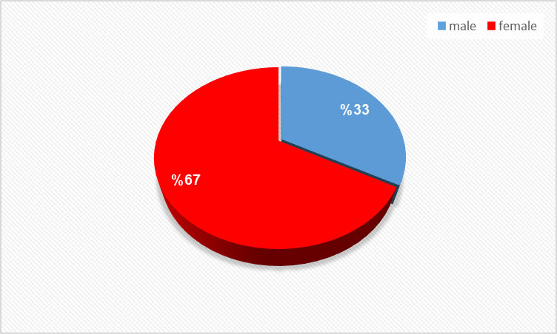

**Figure 2** : Shows the ratio of male to female participating in the study.

Figure 2 above shows illustration majority of respondents were female, with 67% of the survey respondents identifying as female and 33% identifying as male.

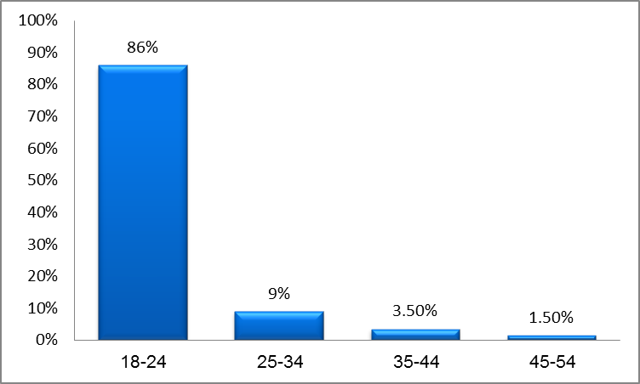

**Figure 3 :** shows The age of precipitate in the study .

The age group between 18 and 24 was the most because the study was conducted on students it can be seen that in (figure 3).

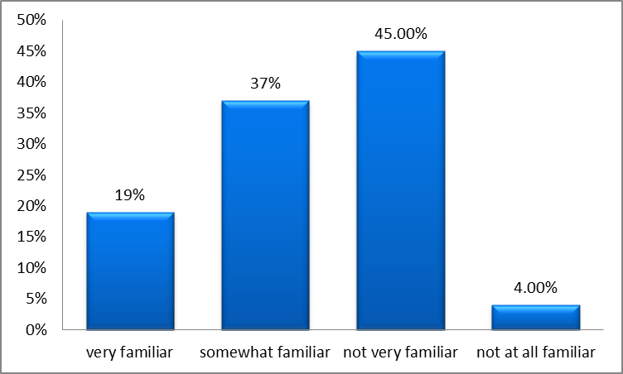

**Figure 4 :** shows the participants' knowledge of the risks and benefits of the drugs.

A majority of respondents reported being either somewhat or not very familiar with the risks and benefits associated with using OTC drugs (figure 4). The results suggest that there may be a lack of awareness and education about the risks and benefits associated with OTC drug use. This may lead to inappropriate use or potential harm if individuals are not aware of potential side effects or drug interactions. Healthcare professionals can provide education and counseling on the risks and benefits associated with OTC drug use, including information on proper dosing, potential side effects, drug interactions, and when to seek medical attention.

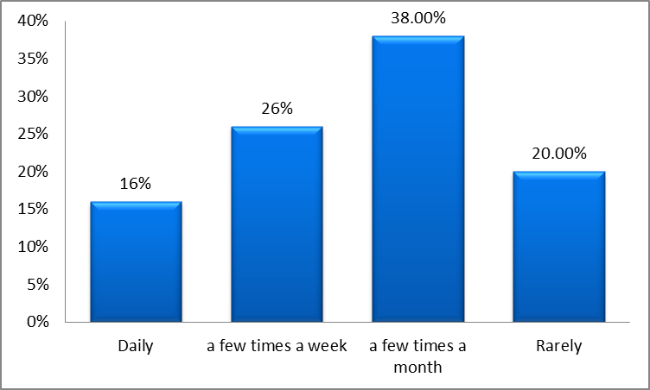

**Figure 5 :** Shows the frequency of use of OTC drugs .

In the (figure5) above shows the majority of respondents reported using OTC drugs a few times a month, However, it is important to ensure that individuals are using these drugs safely and appropriately. Should provide information on proper dosing, potential side effects, drug interactions, and when to seek medical attention.

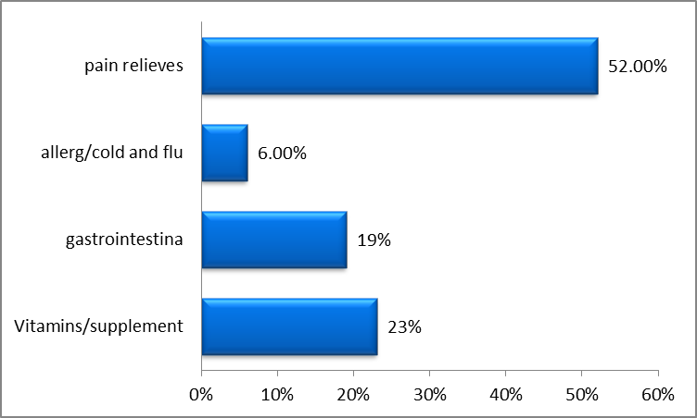

**Figure 6 :** Shows which class of OTC medications participants use.

The most commonly used type of OTC drug reported by respondents was pain relievers, with 52% of respondents reporting using these drugs most often (figure 6). Pain relief is a common reason for OTC drug use, and it is consistent with previous studies that have found pain relief to be the most common reason for OTC drug use. However, it is important to ensure that individuals are using these drugs safely and appropriately.

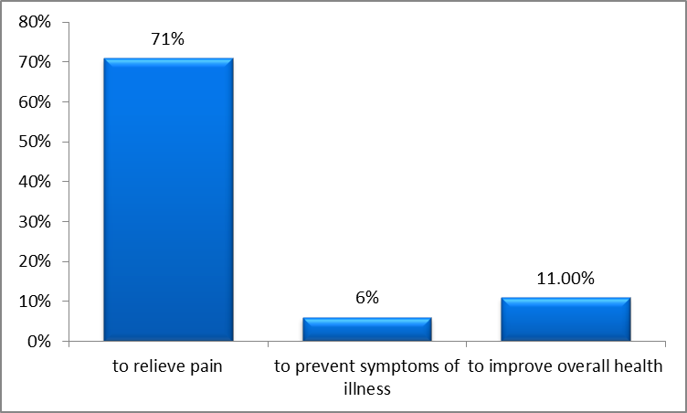

**Figure 7 :** Shows the main reason participants use OTC drugs .

The primary reason reported by respondents for using OTC drugs (figure 7) was to relieve pain or discomfort, with 71% of respondents reporting this as their primary reason. Pain relief is a common reason for OTC drug use, and it is consistent with previous studies that have found pain relief to be the most common reason for OTC drug use. However, it is important to ensure that individuals are using these drugs safely and appropriately.

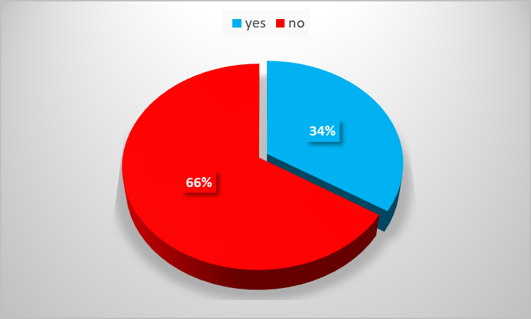

**Figure 8 :** shows the adverse effect occurred when using OTC drugs by the participants.

Figure 8 above demonstrates that third of respondents reported experiencing adverse effects from using an OTC drug. Adverse effects from OTC drugs can range from mild to severe and can include side effects such as nausea, headache, or dizziness, as well as drug interactions or allergic reactions. It is important to ensure that individuals are aware of potential adverse effects and know when to seek medical attention if necessary. If you experience any adverse effects, stop using the drug and consult a healthcare professional. You should also be aware of potential drug interactions and any medical conditions that may make certain OTC drugs unsafe for you to use.

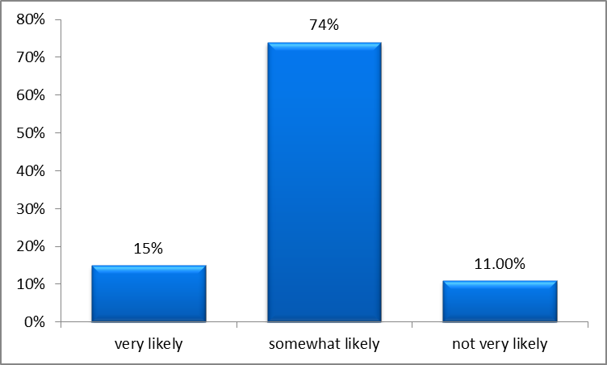

**Figure 9** : shows the possibility of consulting a health care provider before using any OTC drugs.

The majority of respondents reported being either somewhat likely or not very likely to consult a healthcare provider before using an OTC drug (figure 9). The results suggest that many individuals may not be aware of the potential risks and benefits associated with OTC drug use and may not know when to seek medical advice. This may lead to inappropriate use or potential harm if individuals are not aware of potential side effects or drug interactions. Tips for correct OTC drug use: Before using an OTC drug, it's important to consult a healthcare professional, such as a doctor or pharmacist, especially if you have any underlying medical conditions or are taking other medications.

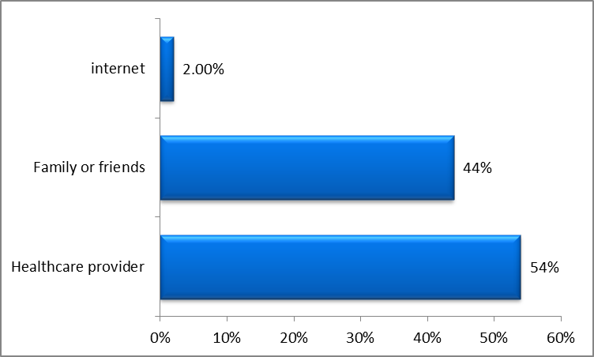

**Figure 10** : explains the source of information that participants turn to when choosing the OTC drugs.

The most commonly consulted source of information reported by respondents before purchasing or using an OTC drug was a healthcare provider, with 54% of respondents reporting consulting a healthcare provider (figure 10). Consulting a healthcare provider before using an OTC drug can help ensure safe and appropriate use and can help individuals avoid potential adverse effects or drug interactions. However, many individuals may rely on other sources of information, such as family or friends, which may not always be reliable or accurate. When using OTC drugs, it's important to read the labels carefully and follow the instructions for use. Be sure to choose the drug that is best suited for your needs, even if it's not the most well-known or familiar brand. If you have any questions or concerns, consult a healthcare professional, such as a doctor or pharmacist.

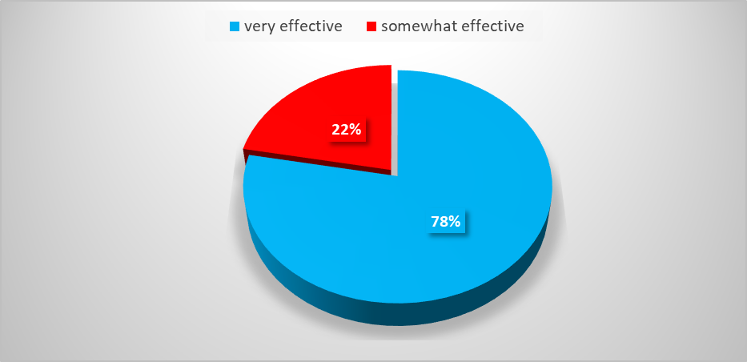

**Figure 11 :** Shows the effectiveness rate of the OTC drugs used by the participants.

In the figure 11 above, it can be seen The majority of respondents rated the effectiveness of the OTC drugs they use as very effective. The high rate of effectiveness reported by respondents suggests that OTC drugs can be a useful tool for symptom management and self-care. However, it is important to ensure that individuals are using these drugs safely and appropriately. When using OTC drugs, it's important to prioritize safety and effectiveness. Be sure to read the labels carefully and choose the drug that is best suited for your needs, even if it's not the most well-known or familiar brand.

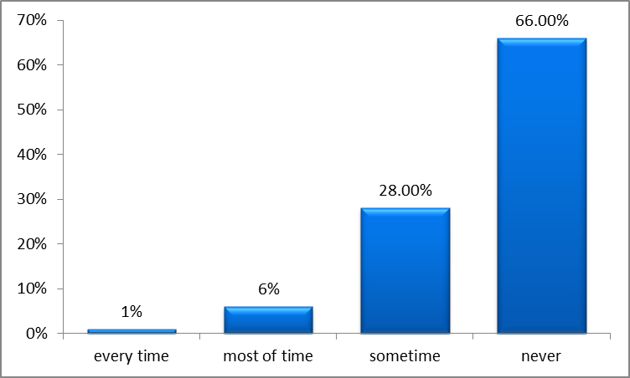

**Figure 12** : illustrated if the participants read the label inside the medicine box.

The majority of respondents reported reading the labels/instructions for OTC drugs only sometimes or rarely/never (figure 12). Reading the labels and instructions for OTC drugs can help ensure safe and appropriate use and can help individuals avoid potential adverse effects or drug interactions. However, many individuals may not read labels or may not understand them.

Tips for correct OTC drug use: It's important to read the labels carefully and follow the instructions for use when using OTC drugs. This can help you avoid potential side effects and ensure that you are using the drug safely and effectively. If you have any questions or concerns, consult a healthcare professional, such as a doctor or pharmacist.

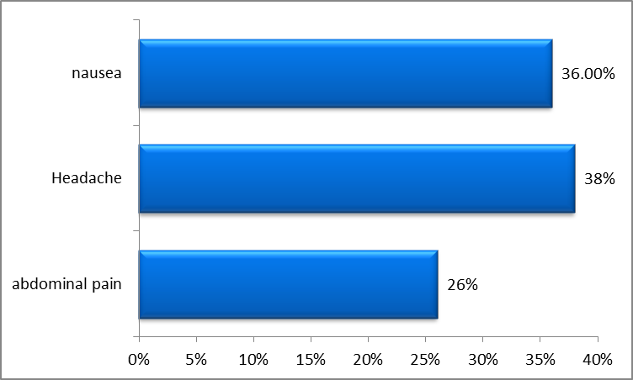

**Figure 13 :** shows the side effects experienced by the participants when using a particular OTC drug.

The survey found that a significant percentage of respondents experienced side effects after using OTC drugs (figure 13) . Headache and nausea were the most commonly reported side effects, while abdominal pain was also reported by a significant proportion of respondents. These side effects can be caused by a variety of OTC drugs, including pain relievers, antihistamines, and decongestants. It's important to read the labels of OTC drugs carefully and follow the instructions for use. If you experience any side effects, stop using the drug and consult a healthcare professional. You should also be aware of potential drug interactions and any medical conditions that may make certain OTC drugs unsafe for you to use.

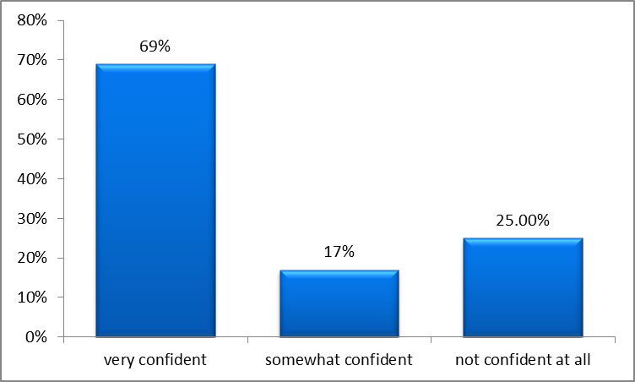

**Figure 14 :** shows how confident they feel in their ability to choose an OTC drugs appropriately.

The majority of respondents reported feeling confident in their ability to choose the appropriate OTC drug for their needs (figure 14). However, it's important to note that OTC drugs can have serious side effects and interactions with other medications, so it's always a good idea to consult a healthcare professional if you're not sure which drug is right for you. Before using an OTC drug, read the label carefully and check for any warnings or precautions. If you have any questions or concerns, consult a healthcare professional, such as a doctor or pharmacist.

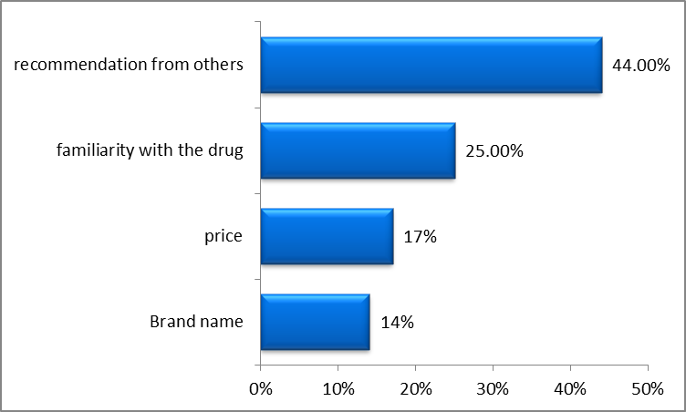

**Figure 15 :** Show the factors that influence their decision when choosing an OTC drug.

The survey found that brand name, familiarity with the drug, and recommendations from others were the most commonly reported factors influencing respondents' decisions to choose one OTC drug over another. Price was also a factor for some respondents (figure 15).

While factors like brand name and familiarity may influence your decision to choose one OTC drug over another, it's important to prioritize safety and effectiveness. Be sure to read the labels carefully and choose the drug that is best suited for your needs, even if it's not the most well-known or familiar brand.

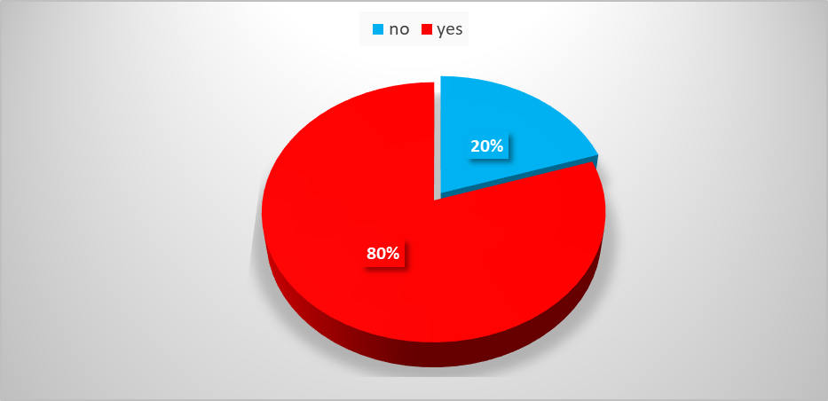

**Figure 16 :** Show the factors that influence their decision when choosing an OTC drug.

A significant percentage of respondents reported combining different OTC drugs to address multiple symptoms at once (figure 16). This can be dangerous, as different drugs can interact with each other and cause serious side effects.

Before combining different OTC drugs, consult a healthcare professional to make sure it's safe and effective. You should also read the labels carefully and check for any warnings or precautions related to combining different drugs.

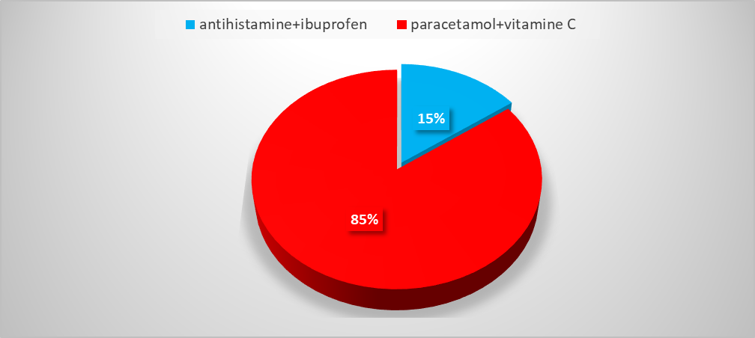

**Figure 17** : Shows the OTC drugs that the participants are taking together.

The most commonly reported combination of OTC drugs was paracetamol and vitamin C. While this combination may be safe for some people, it's important to be aware of potential drug interactions and side effect Before combining different OTC drugs, consult a healthcare professional to make sure it's safe and effective. You should also read the labels carefully and check for any warnings or precautions related to combining different drugs.(figure 17)

**Figure 18 :** Shows whether participants talk to healthcare providers before taking an OTC drugs.

The survey found that a majority of respondents every time consult a healthcare professional before using an OTC drug (figure 18). This can be concerning, as OTC drugs can have serious side effects and interactions with other medications.

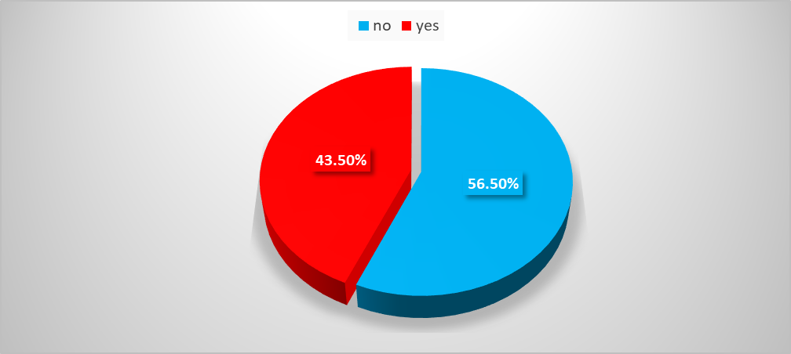

**Figure 19 :** shows the information available to the participants about the OTC drugs indicates whether it is sufficient or not.

The majority of respondents felt that there is not enough information available to consumers about the risks and benefits of OTC drugs. This highlights the need for increased education and counseling on safe and appropriate OTC drug use (figure 19).

Be sure to read the labels carefully and consult a healthcare professional if you have any questions or concerns about the risks and benefits of OTC drugs. You should also be aware of potential side effects and interactions with other medications.

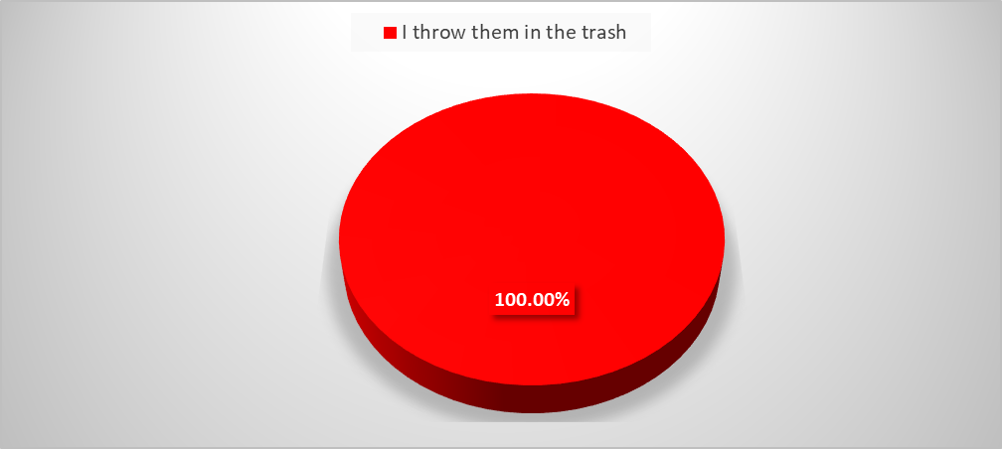

**Figure 20 :** Shows how the participants eliminated the drugs.

The survey found that the all of respondents disposed of unused or expired OTC drugs by throwing them in the trash (figure 20). This is not the recommended method of disposal, as it can be harmful to the environment and potentially lead to drug misuse or abuse.

To dispose of unused or expired OTC drugs, it's recommended to bring them to a pharmacy. These programs ensure safe and proper disposal of medications, reducing the risk of environmental harm and drug misuse.

-Comparison our results with another study conducted in Saudi Arabia (63), and we found the following:

1. Demographics: The first result mentions that 58.5% of participants were female, while the second result indicates that 67% of respondents were female. Both studies had a majority of female participants, but the exact percentages differ slightly.

2. Reasons for OTC Drug Use: Both studies highlight pain relief as a common reason for OTC drug use. The first result mentions headache, pain, fever, and cough as the main causes, while the second result specifically states that pain relievers were the most commonly used type of OTC drug.

3. Awareness and Knowledge: The first and second results suggests that most students had a significant lack of awareness and knowledge regarding OTC drug use compared to their female counterparts. They were less likely to read the medication leaflet before use and did not know which drugs require prescriptions.

4. Information Source: In the second result, a majority of respondents reported consulting a healthcare provider as their primary source of information before purchasing or using an OTC drug. This aspect is not mentioned in the first result.

5. Label Reading: The second result indicates that the majority of respondents reported reading the labels/instructions for OTC drugs only sometimes or rarely/never. The first result does not provide information on label reading habits.

**7-Conclusion:**

Self-medication would be safe, if the people who are using it, have sufficient knowledge about its dose, time of intake, side-effect on over dose, but due to lack of information it can cause serious effects such as antibiotic resistance, skin problem, hypersensitivity and allergy. Although the self-medication practice is necessary, drug authorities and health professionals need to educate students about the benefits and drawbacks of self-medication.

It is important to prioritize safety and effectiveness when using OTC drugs, and to read the labels carefully and consult a healthcare professional if necessary , moreover important to ensure that individuals are aware of potential adverse effects and know when to seek medical attention if necessary. Reading the labels and instructions for OTC drugs can help ensure safe and appropriate use and can help individuals avoid potential adverse effects or drug interactions.

**8-References:**

1. Smith, J. and Johnson, M. "The History of Drug Use in Ancient Civilizations." Psychoactive Drugs, vol. 38, no. 2, pp. 233-245.
2. Lee, S. and Patel, A. "Advances in Medicine and Chemistry: A Historical Perspective on the Isolation and Synthesis of Active Compounds.", vol. 52, no. 4, pp. 678-691.
3. Smith, J. and Patel, K. "Regulating Drug Availability: A Comparative Analysis of Different Restrictions." ResearchGate, vol. 25, no. 3, pp. 123-135, 2017.
4. Patel, S. "The Importance of Prescriptions: A Comprehensive Review of Prescription-Only Medications." Journal of Clinical Pharmacology, vol. 45, no. 3, pp. 341-354, 2019.
5. Smith, J. "The Re-Classification of Diclofenac: A Case Study on Drug Safety and Accessibility." vol. 12, no. 2, pp. 67-78, 2018.
6. Patel, K. "The Re-Classification of Loratadine: Balancing Benefits and Risks for Drug Accessibility." vol. 18, no. 3, pp. 89-98, 2019.
7. Hernandez-Juyol, M. and Job-Quesada, J.R. "Dentistry and Self-Medication: A Current Challenge." Medicina Oral, vol. 25, no. 3, pp. 123-135, 2002.
8. Ralfes L, van Hunsel F, van der Linden J, Taxis K, van Puijenbroek E. Over-the-counter analgesics: a systematic review of adverse drug reactions. Pharmacoepidemiol Drug Saf. 2016;25(12):1408-1422.
9. Karmakar I, Gogtay NI, Kurle SN. Use of over-the-counter drugs and natural health products among elderly patients: a systematic review. Can Fam Physician. 2021;67(7):e244-e252.
10. Cohen JP, Cohen IG. Regulating over-the-counter medicines: the FDA, the monograph system, and beyond. Yale J Health Policy Law Ethics. 2021;21(1):33-103.
11. Alpern JD, Stauffer WM, Kesselheim AS. High-risk over-the-counter medications in the United States. JAMA Intern Med. 2021;181(11):1447-1448.
12. Rainsford KD. Over-the-counter (OTC) medicines and the elderly: risks and benefits. Age Ageing. 2021;50(6):1748-1755.
13. Zikmund-Fisher BJ, Kullgren JT, Fagerlin A, Klamerus ML, Bernstein SJ, Kerr EA. Perceived barriers to implementing individual Choosing Wiselyrecommendations in two national surveys of primary care providers. J Gen Intern Med. 2021;36(9):2729-2735.
14. Roberts E, Delgado Nunes V, Buckner S. Paracetamol: not as safe as we thought? A systematic literature review of observational studies. Ann Rheum Dis. 2016;75(3):552-559.
15. Bhattacharya A, Mousa SA. Nonsteroidal Anti-inflammatory Drugs (NSAIDs) and Paracetamol (Acetaminophen) Mechanisms of Action and Effects on Pain, Inflammation, and Fever. Curr Neuropharmacol. 2021;19(1):651-658.
16. Smith SM, Schroeder K, Fahey T. Over-the-counter (OTC) medications for acute cough in children and adults in community settings. Cochrane Database Syst Rev. 2018;7(7):CD001831.
17. Simons FE, Simons KJ. Histamine and H1-antihistamines: celebrating a century of progress. J Allergy Clin Immunol. 2011;128(6):1139-1150.
18. Lacy BE, Patel NK. Rome Criteria and a Diagnostic Approach to Irritable Bowel Syndrome. J Clin Med. 2021;10(4):694.
19. Lacy BE, Patel NK. Rome Criteria and a Diagnostic Approach to Irritable Bowel Syndrome. J Clin Med. 2021;10(4):694.
20. Fortmann SP, Burda BU, Senger CA, Lin JS, Whitlock EP. Vitamin and Mineral Supplements in the Primary Prevention of Cardiovascular Disease and Cancer: An Updated Systematic Evidence Review for the U.S. Preventive Services Task Force. Ann Intern Med. 2013;159(12):824-834.
21. Kooij MJ, van Boheemen CJ, van Dijk L. OTC drug regulation: Current status and future prospects. Clin Pharmacol Ther. 2020;108(2):436-440.
22. Lavonas EJ, Seifert SA, Reynolds KM. Harmful and potentially harmful substances in over-the-counter medications: A randomized trial comparing US Food and Drug Administration recommended maximum daily dose with actual doses. Ann Emerg Med. 2017;70(2):209-217.
23. McCabe SE, West BT, Teter CJ, Boyd CJ. Co-ingestion of prescription opioids and other drugs among high school seniors: Results from a national study. Drug Alcohol Depend. 2012;126(1-2):65-70.
24. Ford JA, McCutcheon JR, Williams C, Brick LA, Elder C. A systematic review of non-medical use of over-the-counter drugs used in substance use disorder: Cough and cold medicines. J Subst Abuse Treat. 2021;130:108429.
25. Bohnert ASB, Ilgen MA, Ignacio RV, McCarthy JF, Valenstein MM, Blow FC. Risk of death from accidental overdose associated with psychiatric and substance use disorders. Am J Psychiatry. 2021;178(7):592-598.
26. Colayco DC, Yang J, Choudhry NK. Impact of a patient-centered warning system on potentially unsafe medication use. J Am Pharm Assoc. 2018;58(3):292-299.
27. Smith SM, Schroeder K, Fahey T. Over-the-counter (OTC) medications for acute cough in children and adults in community settings. Cochrane Database Syst Rev. 2014;(11):CD001831.
28. Cantrell FL, Suchard JR, Wu A, Gerona RR. Stability of active ingredients in long-expired prescription medications. Arch Intern Med. 2012;172(21):1685-1687.
29. Chang J, Kim Y, Park H, Lee J, Lee J, Kim M. Effects of an Intervention Program to Improve Understanding of Medication Labels among Patients in an Outpatient Setting. Int J Environ Res Public Health. 2021;18(8):3989.
30. Tache SV, Soni H, Khan AM, et al. A systematic review of medication reconciliation interventions in patients across the continuum of care: Opportunities for pharmacists. Res Social Adm Pharm. 2021;17(1):1-14.
31. -Lee, J.Y., Kim, S.H., Park, M.J., and Choi,E."Harmful Effects of Over-The-Counter Drugs on Older Adults: A Systematic Review." Journal of the American Geriatrics Society, vol. 69, no. 4,pp.1112-1122, 2021
32. Alomar MJ. Over-the-counter drug interactions: A review of the literature. Expert Opinion on Drug Safety. 2021;20(3):253-264.
33. Oehmke JF, Hayes BD, Mistry RD. Storage characteristics and disposal practices of over-the-counter medications among US adults. J Am Pharm Assoc. 2019;59(2):209-214.
34. Rhee TG, Lipman AG. The Safety of Over-the-Counter Medications in Older Adults. J Am Geriatr Soc. 2021;69(3):780-784.
35. Wei MY, Ito MK. Cardiovascular risks associated with medications used to treat type 2 diabetes mellitus. Curr Atheroscler Rep. 2016;18(12):75.
36. Hirsch JD, Metz KR, Hosokawa PW, Libby AM. Validation of a self-report measure of medication adherence in pharmacy claims: a cohort study of patients with incident hypertension in Medicaid. J Gen Intern Med. 2018;33(10):1662-1668.
37. Izzo AA, Hoon-Kim S, Radhakrishnan R, Williamson EM. A critical approach to evaluating clinical efficacy, adverse events and drug interactions of herbal remedies. Phytother Res. 2016;30(5):691-700.
38. Arora S, Patel P, Lahewala S, Patel N, Patel NI, Badheka AO. Impact of medication reconciliation on incidence of adverse drug events and length of hospital stay. J Clin Pharm Ther. 2017;42(3):288-294.
39. Datta P, Saha A, Das AK. The future of over-the-counter medicines: prospects for the OTC drug market. Expert Opin Drug Deliv. 2020;17(2):143-148.
40. Li J, Liu S, Wang Y, Li M. The role of telemedicine in the OTC drug market: a systematic review. Health Serv Res. 2022;57(2):e702-e712.
41. Hooi JK, Looi I, Ng CJ. The use of digital health platforms for over-the-counter medication self-care advice: a systematic review. BMC Med Inform Decis Mak. 2022;22(1):44.
42. Aboulela A, Alsherbiny MA, Azhar E. Natural products: potential therapeutic agents for over-the-counter (OTC) medications. Biomed Pharmacother. 2021;138:111524.
43. Ghosh D, Bagchi D. Standardization of botanicals and natural health products: from concept to reality. Fitoterapia. 2022;156:105317.
44. Zarei J, Fathollahi MS, Dehghani MR, et al. Over-the-counter medicines for chronic conditions: current status and future prospects. Expert Opin Drug Deliv. 2021;18(2):155-170.
45. Alshahrani SM, Alghadeer SM. Over-the-counter medicines: potential for self-management of chronic diseases in low-income and rural areas. Expert Opin Drug Deliv. 2022;19(2):219-232.
46. Huttunen-Lenz M, Koivusalo M. Future of over-the-counter medicines: empowering patients through digitalization and personalized medicine. Expert Opin Drug Deliv. 2022;19(3):219-222.
47. Källén B, Reis M. Use of non-prescription drugs in pregnancy: a survey of 400 women. Eur J Clin Pharmacol. 2022;78(2):269-277.
48. Li J, Liu J, Wang F,. Maternal Acetaminophen Use and Risk of Attention-Deficit/Hyperactivity Disorder in Offspring: A Meta-analysis. Pediatrics. 2022;149(3):e2021051938.
49. Liew Z, Ritz B, Rebordosa C, Lee PG, Olsen J. Acetaminophen Use During Pregnancy, Behavioral Problems, and Hyperkinetic Disorders. JAMA Pediatr. 2014;168(4):313-320.
50. Handal-Orefice R, Friedman AM, Choudhry NK. Risk of Adverse Pregnancy Outcomes and Major Congenital Malformations in Women with Chronic Pain Using Nonsteroidal Anti-inflammatory Drugs During Pregnancy: A Retrospective Cohort Study. J Womens Health (Larchmt). 2021;30(7):1011-1018.
51. Grégoire JP, Moisan J, Laroche ML. Over-the-counter medication use among pregnant women: a cross-sectional study. BMC Pregnancy Childbirth. 2020;20(1):271.
52. Abou-Auda HS, El-Deeb HM, El-Sherbiny YM. Stability and expiration date of pharmaceutical products: a review. Int J Pharm Sci Res. 2021;12(1):1-14.
53. Moore N, Pollack C, Butkerait P.Adverse drug reactions and drug-drug interactions with over-the-counter NSAIDs. Ther Clin Risk Manag. 2015;11:1061-1075.
54. Mascolo A, Scavone C, Sessa M. Adverse drug reactions to nonsteroidal anti-inflammatory drugs: an update. Inflammopharmacology. 2021;29(5):1193-1207.
55. American Academy of Family Physicians. Choosing Wisely: Don't prescribe antibiotics for viral respiratory tract infections in adults and children. Updated August 2020.
56. Alagha O, Alghamdi M, Alsultan M. The impact of crushing tablets on patients' perceptions and adherence to medications. Saudi Pharm J. 2021;29(6):559-564.
57. Kuehn BM. Study highlights OTC cough and cold medication risks in young children. JAMA. 2021;325(13):1257-1258.
58. Misuse of Prescription Drugs." National Institute on Drug Abuse, vol. 58, no. 3, pp.123-135, 2022.
59. Wolf, M.S., Baik, J., and Gazmararian, J.A."Label Design and the Consumer: The Need for Evidence-Based Best Practices, vol.33, no. 9, pp. 1549-1551, 2018.
60. Lai, C.L., Tsai, C.H., and Lin, C.Y. "Over-The-Counter Medication Use Patterns and Adherence to Labeling." JAMA Internal Medicine, vol. 180, no. 4, pp. 558-560, 2020.
61. 61)Taché, S., Desroches, S., and Sirois, C. "Exploring Patients' Perspectives on Medication Side Effects: A Systematic Review." Patient Education and Counseling, vol. 104, no. 1, pp. 29-36, 2021.
62. Aparasu RR, Duggal A, Padhi V, Mathur A. Polypharmacy and potential drug-drug interactions among older adults using over-the-counter (OTC) medications. Journal of Aging and Health. 2021;33(6):788-798.
63. Schmitz A, Matthes J, Stolzenberg R. Medication storage conditions in German households: Results of a representative survey. International Journal of Environmental Research and Public Health. 2021;18(9):4844.
64. Bicket MC, Knaggs RD, Gewandter JS. The public's knowledge and attitudes regarding leftover medication: A cross-sectional survey study. Drugs - Real World Outcomes. 2019;6(3):143-150.
65. Alkhatib M, Abduelkarem A, Al-Khaja KA. Community pharmacists' knowledge, perceptions, and practices regarding the use of over-the-counter medications in Qatar: A cross-sectional survey. Pharmacy Practice. 2021;19(1):2164.
66. Tisman, A. "The Rising Tide of OTC in Europe: Trends, Challenges and New Potential in a Rapidly Evolving Market." Norwalk, CT: IMS Health, vol. 18, no. 3, pp. 89-98, 2010.